**Assignment 1**

* **Requirement Gathering for Health Care:**

**Request for Proposal (RPF):**

An Online Health Care system should be made. It should consists the details of registered Clinics, Hospitals and Pharmacies with their provided services. Users can register as a Doctor, Patient , Clinic, Hospital or Pharmacy. The registered Doctors should be listed in the site along with registered clinics,hospitals and pharmacies. User can have appointment to clinic,hospital or doctor. There can also be consultation with doctor directly. The billing can be done through payment like esewa to registered clinic/hospital/doctor/pharmacies. There can also be Discussion section to write about the problems related to users.

**Collecting Information:**

When collecting information from key stakeholders, it is essential to focus on two main questions that should serve as guidelines for the overall requirements gathering process.

1. How can an this system contribute to your practice’s strategic goals?
2. What features are the best for achieving your practice’s strategic goals?

So, this may include meeting sample like:

Meeting Notes

Date: Sept 7, 2021

Agenda:

* Discussion about the proposed site.
* Cost finalization.
* Gathering info for design.

Meeting Notes:

1. User friendly site to be made.

Decision Made:

1. Project Accepted.
2. Design for site finalized.

Action Items:

Discovery Questions

|  |  |
| --- | --- |
| **Questions/ Thoughts** | **Answers** |
| Who will be using the new system? | It should be focused to give public a online health care options. So, the system is frequently used by patients , doctors, pharmacies and admin to update regarding new registered details or for removing existing details. |
| So the users can register using any of the options. But how will be the authenticity be done if the doctor/pharmacy/clinic registered directly ? So I recommend admin verify before these registration.. do you consider this ? | Yeah definitely, it would be better if the users are real and valid. So, that should be done. |
| What patient population are we documenting? (i.e., pediatrics, geriatrics, patients, etc.) | There can be different categories of patients obviously i.e pediatrics, geriatrics but all can be kept under patients. |
| Should the payment system be other than esewa? | Since esewa is popular, it should be used as a payment method. Other payments would be plus if they could be add`ed like khalti. |
| What database to use? | MySQL or Posgres, any! |
|  |  |

-

**Analyzing and drafting requirements**

After Analyzing , the entities may include:

Online Health Care System (admin) - admin_id,admin_name,admin_password, doctor_id, doctor_name

Clinic - clinic_id ,name,location, services

Hospital - hospital_id, name, location, services

Pharmacy - pharmacy_id,name, location

Medicine - med_id, name, brand,price

Doctor - doctor_id, doctor_name, phone_no,qualification, specialization(service)

Patient - p_id ,password, p_name, dob, sex, address ,phone, blood_group

History - disease_history , treatment

Appointment - p_id , doctor_id , doctor_name, date , time

Consultation - c_id, doctor_id, date

Report - report_id, p_id, name, report, comments

Feedback - id,doctor_name, comment

Discussion - p_id, description

Billing - id, amount , type

* **Create a Crow’s Foot ERD**

Each of the MegaCo Corporation’s divisions is composed of many departments. Each department has many employees assigned to it, but each employee works for only one department. Each department is managed by one employee, and each of those managers can manage only one department at a time.

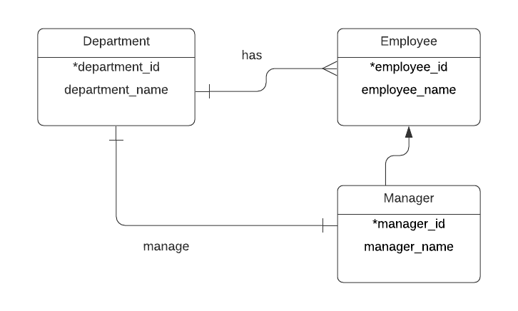

During some period of time, a customer can download many ebooks from BooksOnline. Each of the ebooks can be downloaded by many customers during that period of time.

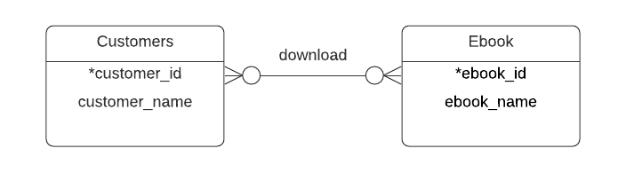

An airliner can be assigned to fly many flights, but each flight is flown by only one airliner.

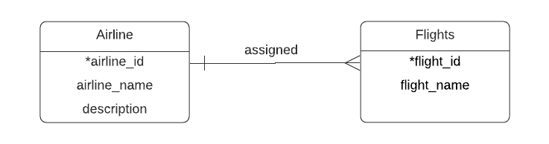

The KwikTite Corporation operates many factories. Each factory is located in a region, and each region can be “home” to many of KwikTite’s factories. Each factory has many employees, but each employee is employed by only one factory.

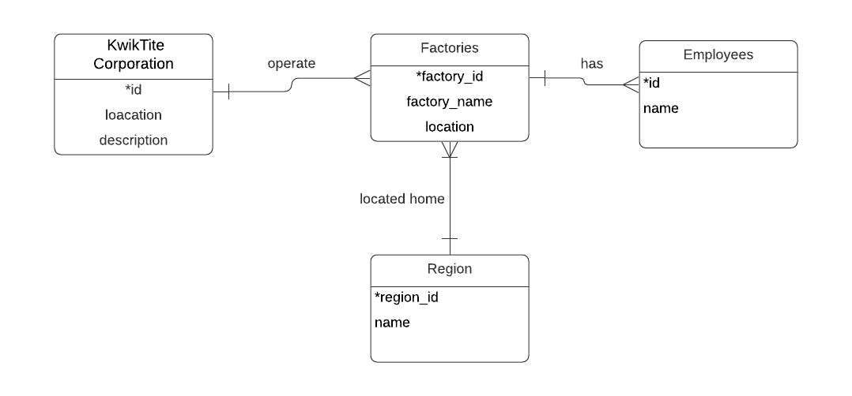

An employee may have earned many degrees, and each degree may have been earned by many employees.

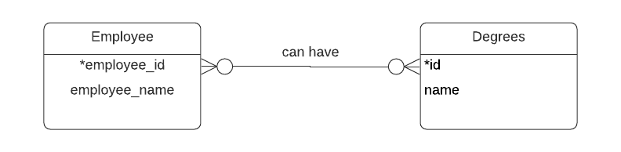

For a company with the following business rules

* Each sales representative writes many invoices.
* Each invoice is written by one sales representative.
* Each sales representative is assigned to one department.
* Each department has many sales representatives.
* Each customer can generate many invoices.
* Each invoice is generated by one customer.

* submitted late because I was out when given assignment yesterday and I had prepared only requirement gathering. so crow’s foot representation was done after today’s session and submitted with little improved requirements.

